[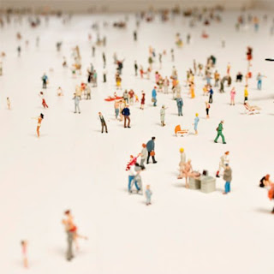](http://1.bp.blogspot.com/-iyAbqHkT0uM/Tobd6UjYUTI/AAAAAAAAAlk/BIpGWhXa0bY/s1600/Rolf-Sachs-Alone-In-A-Crowd-Table-2.jpg)

***If no one knew anybody, or if everybody knew everybody, then I believe, no one would have to eat alone tonight.***

Nor would anyone need to search for a face in the crowd. I somehow feel strongly that the first case might work out much better than the second one.

*I've walked the distance, I paid my dues and tried to have a go at what I thought I knew was real,*

*held no appeal.  
I've been to places, I've seen the tidings,  
I bought a book of rules for every coin that I could steal  
And so I came to gaze upon the stars, when they were yet unborn  
And consequently, tear at my old scars, and the mask I had outworn*

~Roses (Poets of the fall)

**Of late, I've grown weary and bored. Of listening, and talking, and listening, and talking still. I want to slow down a bit, get off the train, and walk some distance on the two parallel tracks, barefoot. I want to sit on a bench and watch the world go by, doing what it does everyday, running.**

**I want to lie down and watch the stars run on their routine course throughout the night and wish, that tomorrow they start from the west. I wish to unlearn what I have learnt, and learn all over again. I wish to read literature and learn to write, again. And I just don't wish to wish anymore.**

*I've heard the rumors, started fires, I sowed a sordid lot of plays for keeps for what I need,*

*behold the demons that I freed.  
I've tried my best at wearing the hard hat, but healing doesn't seem to happen when you hide away the seed  
And so I came across the medicine man, and he showed me what I'd forlorn   
For if I'm stayed it happens by my own hand, and my own voice full of scorn.*

~Roses

What did I just write? Nothing that was mine. I'm just breaking off from the yardstick straight line and headed out for a while. I have been bored for too long. Nothing happens, now might.

[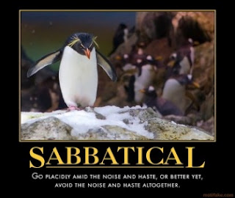](http://1.bp.blogspot.com/-iWFcd4voRmY/Tobdda_rzeI/AAAAAAAAAlg/5aFRR0XTs9U/s1600/sabbatical.jpg)